Majok Ring

CORE 01

Kitchen

8 March 2015

The universe, remaining a vastly unexplored territory, will never be fully explained or known within any respect. Other than our current limitations in terms of physically exploring the universe, this is due to a clash of perspectives in terms of how to approach certain subjects. The ambiguity of language can cause confusion and direct focus towards superficial definition rather than an in depth meaning. As Carl Sagan states within his essay, “Can We Know the Universe?”, “Science is a way of thinking much more than it is a body of knowledge. Its goal is to find out how the world works, to seek what regularities there may be, to penetrate the connections of things” (Sagan 1). With this in mind, it is our responsibility as educated individuals to continue our efforts to understand this universe we are in, its laws, causes, effects, and ultimately use this knowledge apply to our own technology/research. In order to accomplish this, we must first have a proper understanding of how our own brains work and which conditions are most optimal for learning. Since brain works as a foraging learner, continuously searching for pieces of information which can clarify understanding, it should only be natural that our explanations follow this process and establish a model based system of learning.

The difference between connection building and critical thinking is essentially only held by our irises. Our vision remains a highly excellent resource when learning as models, charts, and graphs while simple in nature, may allow us to rebuild connections and pose our own questions. When using descriptive and specific names such as KEPLER-22b, or ALPHA CENTAURI Bb, we are not presenting any visual aspects or keywords which prod the reader to create a mental image and establish their own meaning to the name. Although it is beneficial to have be familiar standard terminology, it can become an issue when it devolves simply into a shallow memorization of definitions. Without being able to look at visual elements and start to make our own connections and assign meaning to the visuals, we hinder the critical thinking process.

Figure 2

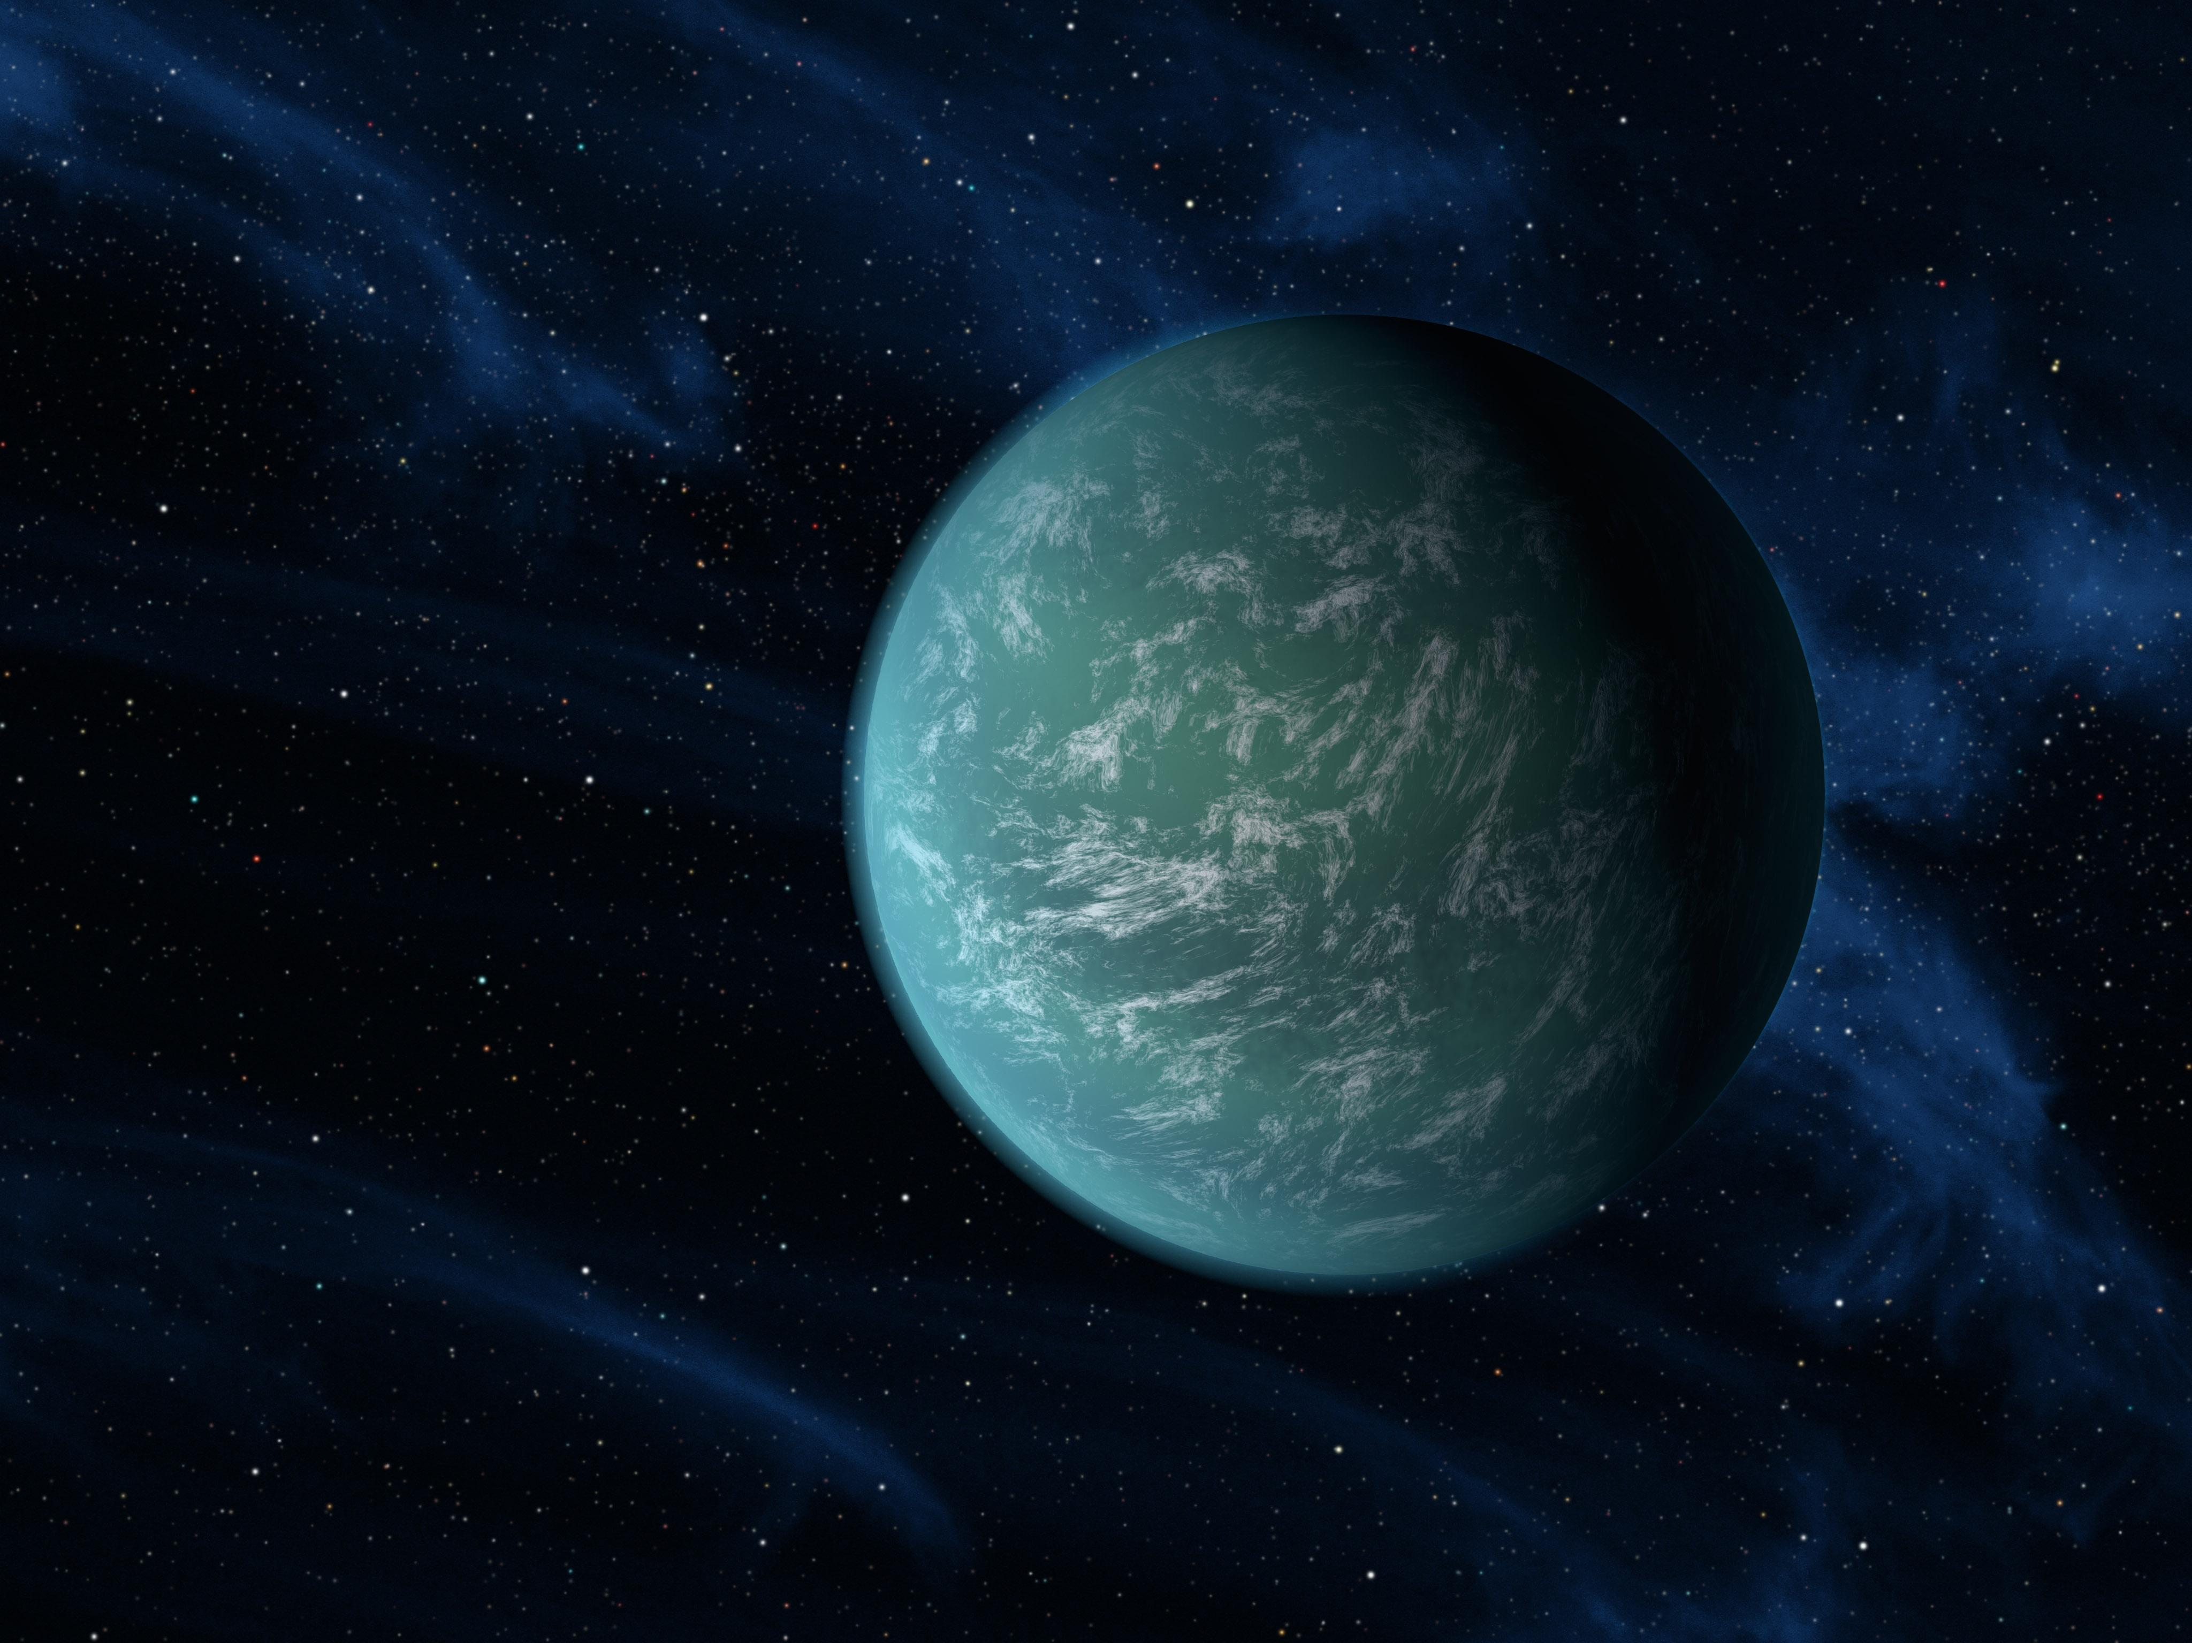

Figure : Kepler-22b, a planet known to comfortably circle in the habitable zone of a sun-like star. It is the first planet that NASA's Kepler mission has confirmed to orbit in a star's habitable zone – Source: NASA.gov

Image credit: NASA/Ames/JPL-Caltech

When we are presented with specific names such as KEPLER-22b, or ALPHA CENTAURI Bb, we should in theory only have one exact image of these exoplanets as they are extremely descriptive and cannot be confused with another. This is due to their explicit naming system which relies on alphanumeric characters, dashes, and subscripts. Now with all of this information readily given to you, you should a clear mental image correct? Of course not. These names fail to inspire thought and creativity as the average individual cannot decipher meaning from simply from names or definitions. As indicated in figure 1, Kepler-22b is a light blue planet containing a spare array of clouds within its atmosphere. By being able to see this image, we commit to a higher level of thinking as we focus our attention to the main features of the planet and ask critical questions. Is that water or simply gas? Is this planet habitable? Where is it located within our galaxy? What similarities does it share with our planet? This is simply the beginning. As each individual views this image, they can choose what points are most important or has the most relevance.

According to Hadhazy within his essay, “What’s in a NAME?” the pros of this naming systems are outweighed by the cons in terms of real life application and relatability. Here astrophysicist and planetary scientist Sara Seager describes the pros as having a “functional universality to scientists around the world; anyone can go and look up an exoplanet by its basic, agreed-upon designation” (Hadhazy 3). Although the benefits are purely functional such as the explicit names and unique structure, we cannot ignore the lack of inspiration which comes from these names. This relates well to Lyra’s statement “The names are boring and don't resonate with non-scientist audiences.” (Hadhazy 3).

As we continue to develop new theories and connections, we must face another key issue in terms of precision of language. Proof. No matter how solid or even baseless the evidence may be, the vital determinant is how we present our evidence in terms of providing a solid argument with clear talking points. We must take our audience/readers into consideration and structure our findings to accommodate them. Take for example a complicated aspect such as the multiverse, which is a hypothetical set of multiple possible universes that exist to form our reality. The multiverse can exist through numerous names such as alternate universes, quantum universes, parallel worlds, and alternate realities. It is a well debated topic which is most known for its lack of falsifiable evidence and practical applications.

Figure

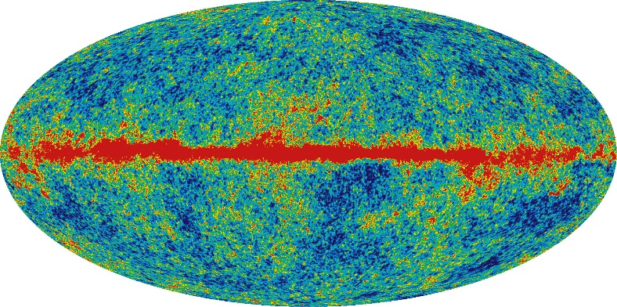

Figure 2: A rendering of the multiverse. “Laura Mersini-Houghton claims that the WMAP cold spot may provide testable empirical evidence for a parallel universe within the multiverse.” Source: map.gsfc.nasa.gov

As shown within figure 2, the multiverse remains to have a large concentration of worlds within the center following the theory of the big bang. As where the universe started with an explosion where it is still expanding, we can see the concentration or universes dispersing throughout and is sparser on the outer edges. Although this is an interesting rendering, we should note that this model is not the most clear as it requires extensive knowledge on the subject and does not convey the same meaning to everyone.

Figure

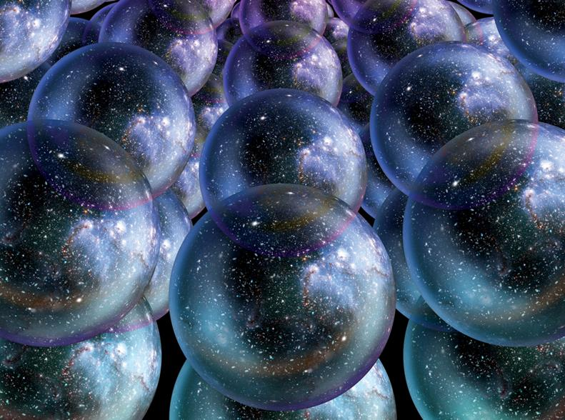

Figure 3: A graphic rendering of the multiverse. Displays multiple universes in synchronization as they follow a natural ordering. Source: Richard Dawkins Foundation

Now in comparison with figure 2, figure 3 remains the more effective mode of communication for ideas. This version while containing the same exact reasoning/conclusions, proves to connect more with the viewers and leads them to understand the core concepts more quickly. Instead of looking at a 2 dimensional image with two simple values of red and blue, we are viewing an image which presents the multiverse as an infinite array of universes in which are arranged in ordered pairs. The universes are each within their own bubbles which serve as boundaries. Now with this image, we form more questions and think critically while applying it to what we know. If each universe has its own boundaries, does this mean that there are gaps within the universe? Areas where nothing exists at all, no forms of matter or particulates drifting? Is there a certain gravity between the universes? If two universes were to potentially collide, what would be the outcome? These questions could only have been inspired by having an image or model in mind. By presenting the mind with something to view and focus on, we are exercising our abilities in connection making and being creative in our conclusions.

As we focus further on expanding our understanding of the universe, we must realize that this can only be accomplished through cooperative efforts such as the sharing of research and findings. In terms of science, the number one hindrance to accumulating the public’s interest and also communicating research is ambiguous language. Through history we have seen that although certain concepts remain the same in principle, their meanings can change due to public perception and assigned meanings. This example of the signified and the signifier is presented through Foucault’s “Order of Things” as he states that “In any given culture and at any given moment, there is always only one episteme that defines the conditions of possibility of all knowledge, whether expressed in a theory or silently invested in a practice” (Foucault 168). When we choose our own origins and model the universe based upon our own perspectives, it is imperative that we use precise language which serves the purpose of implementing an image into the reader’s mind all the while encouraging him/her to think critically. This can be accomplished myriad different ways, but most notably occurs through the visual process such as models, graphs, and charts. This is basic language which anyone can interpret and apply within their own research.

Works Cited

"Big Bang Blunder Bursts the Multiverse Bubble." Richard Dawkins Foundation ICal. N.p., 07 June 2014. Web. 09 Mar. 2015.

Foucault, Michel. Order of Things: An Archaeology of the Human Sciences. By Michel Foucault. New York: Vintage, 1966. 46-51. Print.

HADHAZY, ADAM. "What's In A NAME?" *Discover* 35.6 (2014): 64-71. *Academic*

*Search Complete*. Web. 3 Mar. 2015.

Monfardini, Elisabetta, et al. "Vicarious Neural Processing Of Outcomes During

Observational Learning." *Plos ONE* 8.9 (2013): 1-16. *Academic Search*

*Complete*. Web. 3 Mar. 2015.

"*Multiverse or Meta-Universe."* Multiverse or Meta-Universe. N.p., n.d. Web. 09 Mar. 2015.

Nohl, Arnd-Michael. "Typical Phases of Transformative Learning: A Practice-Based

Model." *Adult Education Quarterly* 65.1 (2015): 35-49. *Academic Search*

*Complete*. Web. 3 Mar. 2015.

"Tests of Big Bang: The CMB." WMAP Big Bang CMB Test. N.p., n.d. Web. 09 Mar. 2015.